**KOLEGJI UNIVERSUM**



Programi Shkenca Kompjuterike / Viti I / Semestri 2

Lënda: Hyrje ne Struktura te te Dhenave

Chapter 5 – Fundamentals of Computer Programming with C#

Studentja: Prof.Dr:

Elsira Kabashi Muzafer Shala

Asistenti: Laberion Zebica

Prishtinë 2021

1. Write an if-statement that takes two integer variables and exchangestheir values if the first one is greater than the second one.

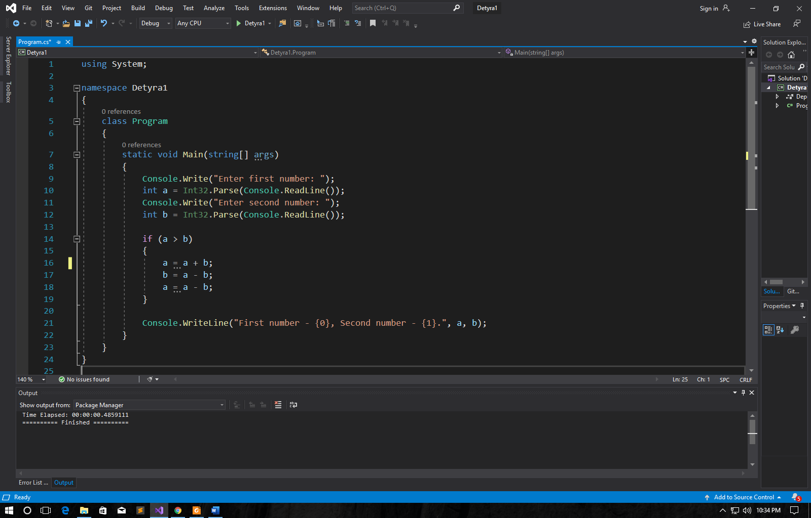

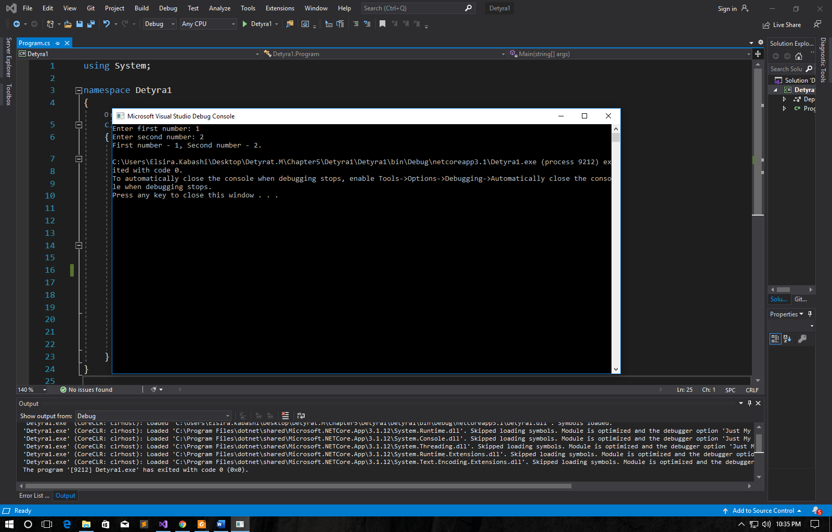

1. Write a program that shows the sign (+ or -) of the product of three real  
   numbers, without calculating it. Use a sequence of if operators.

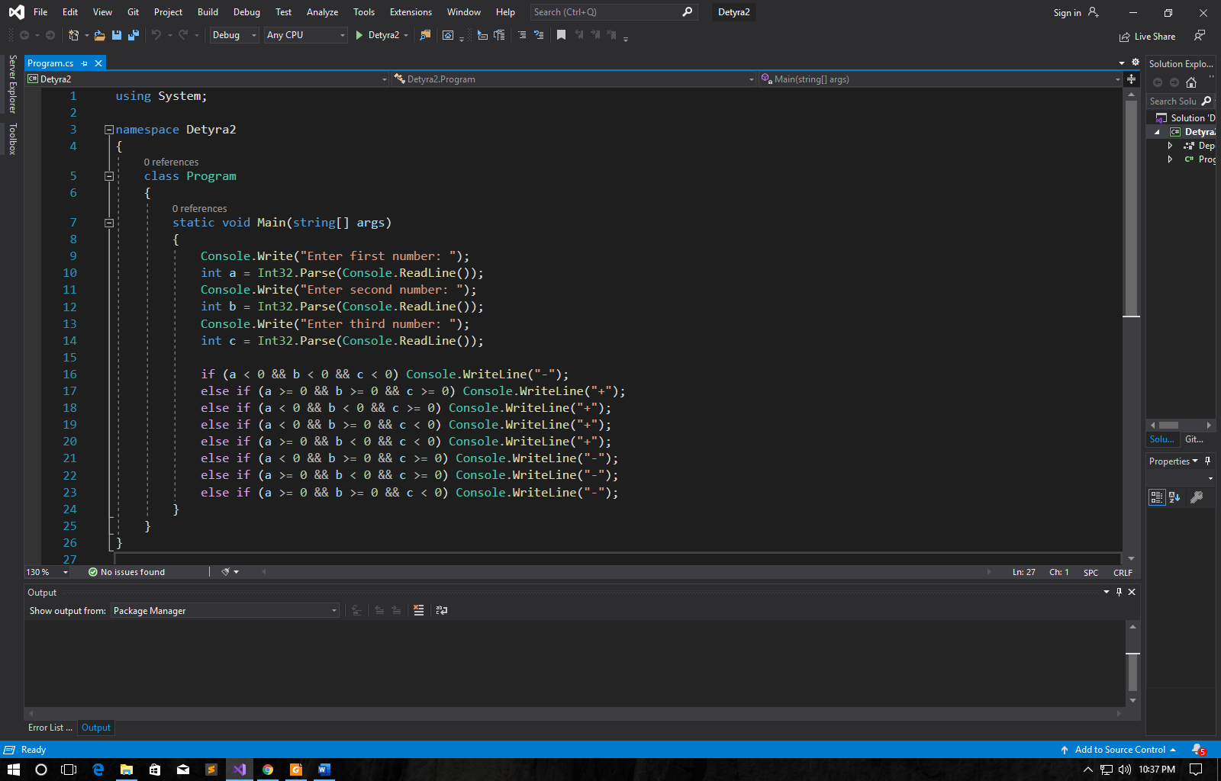

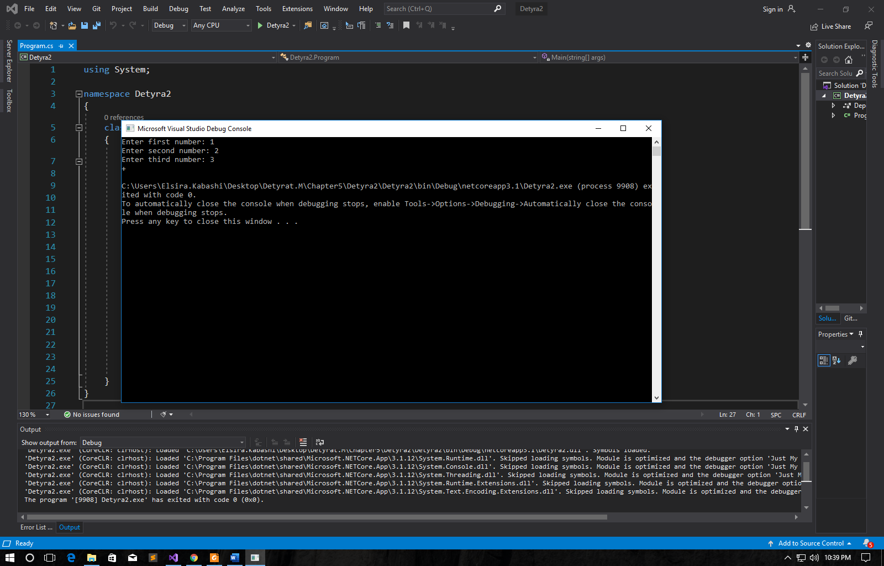

1. Write a program that finds the **biggest of three integers**, using nested  
   **if** statements.

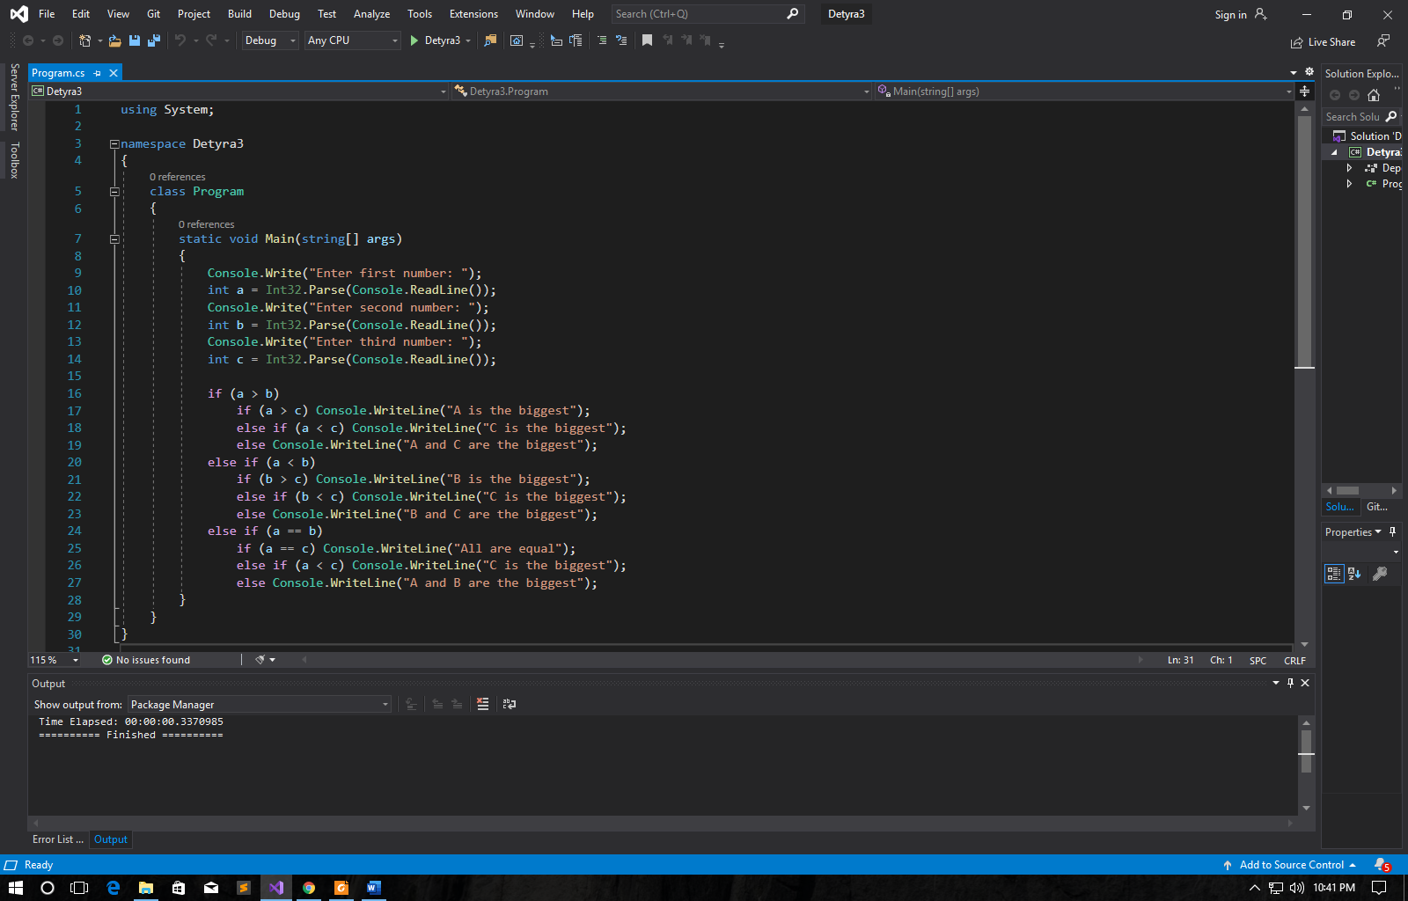

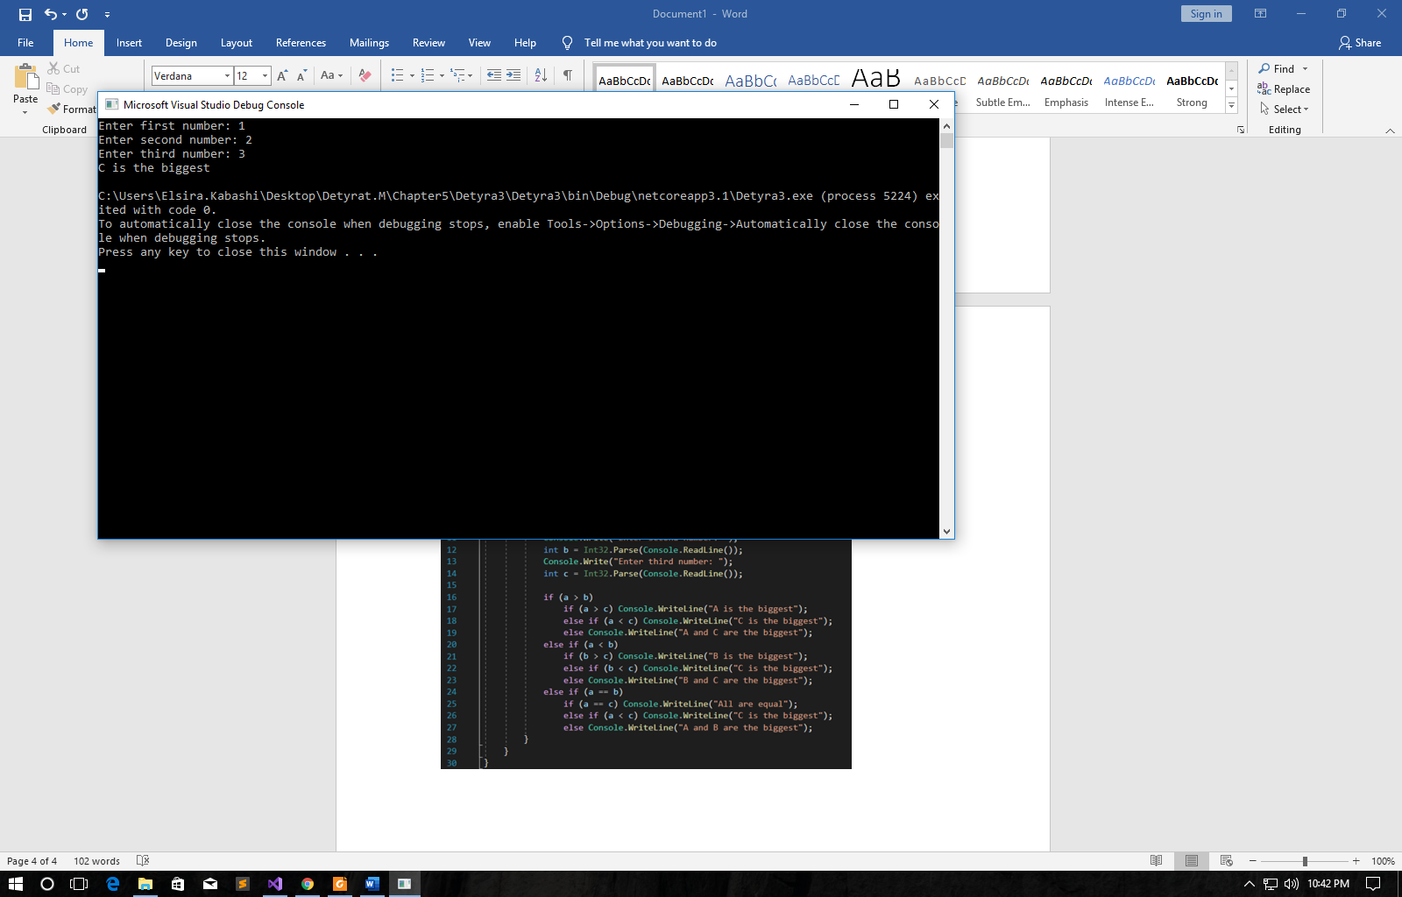

1. **Sort 3 real numbers** in descending order. Use nested **if** statements.

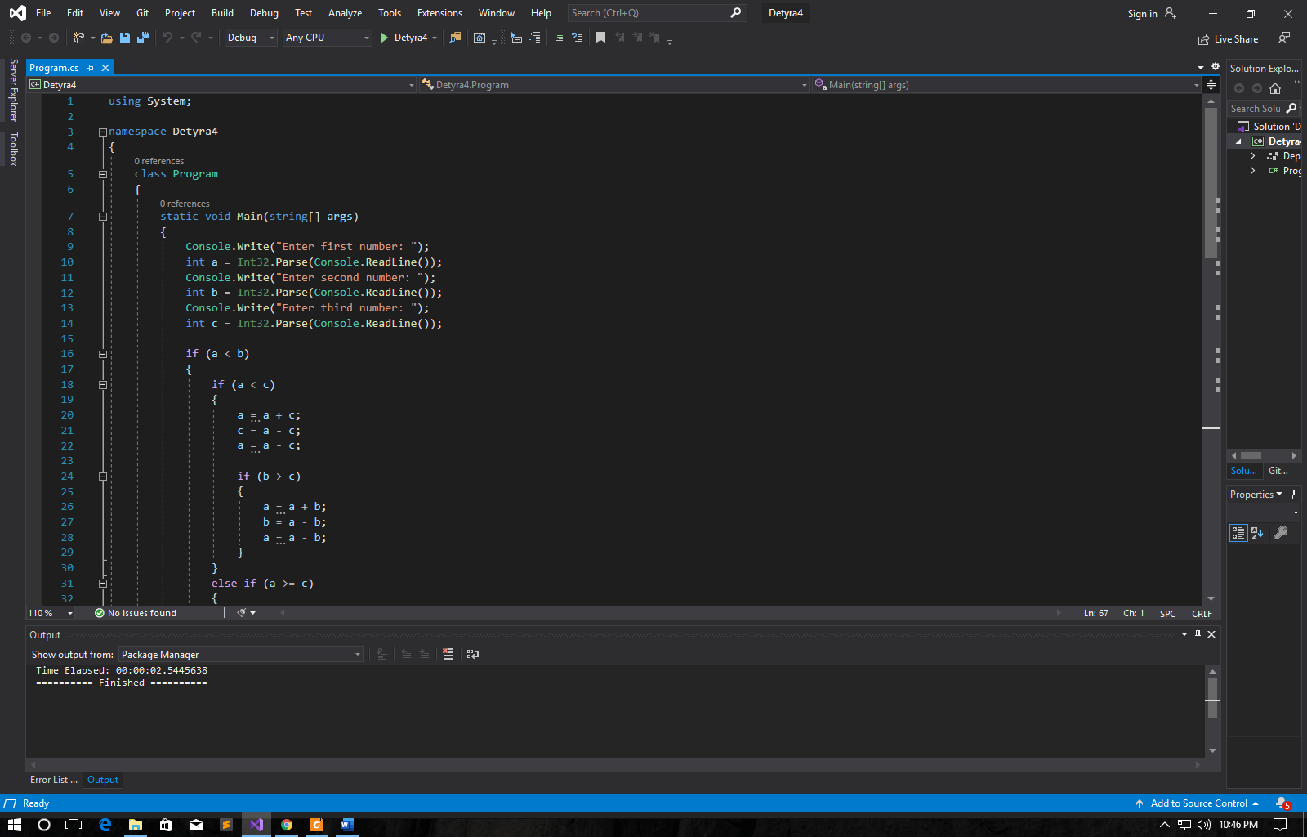 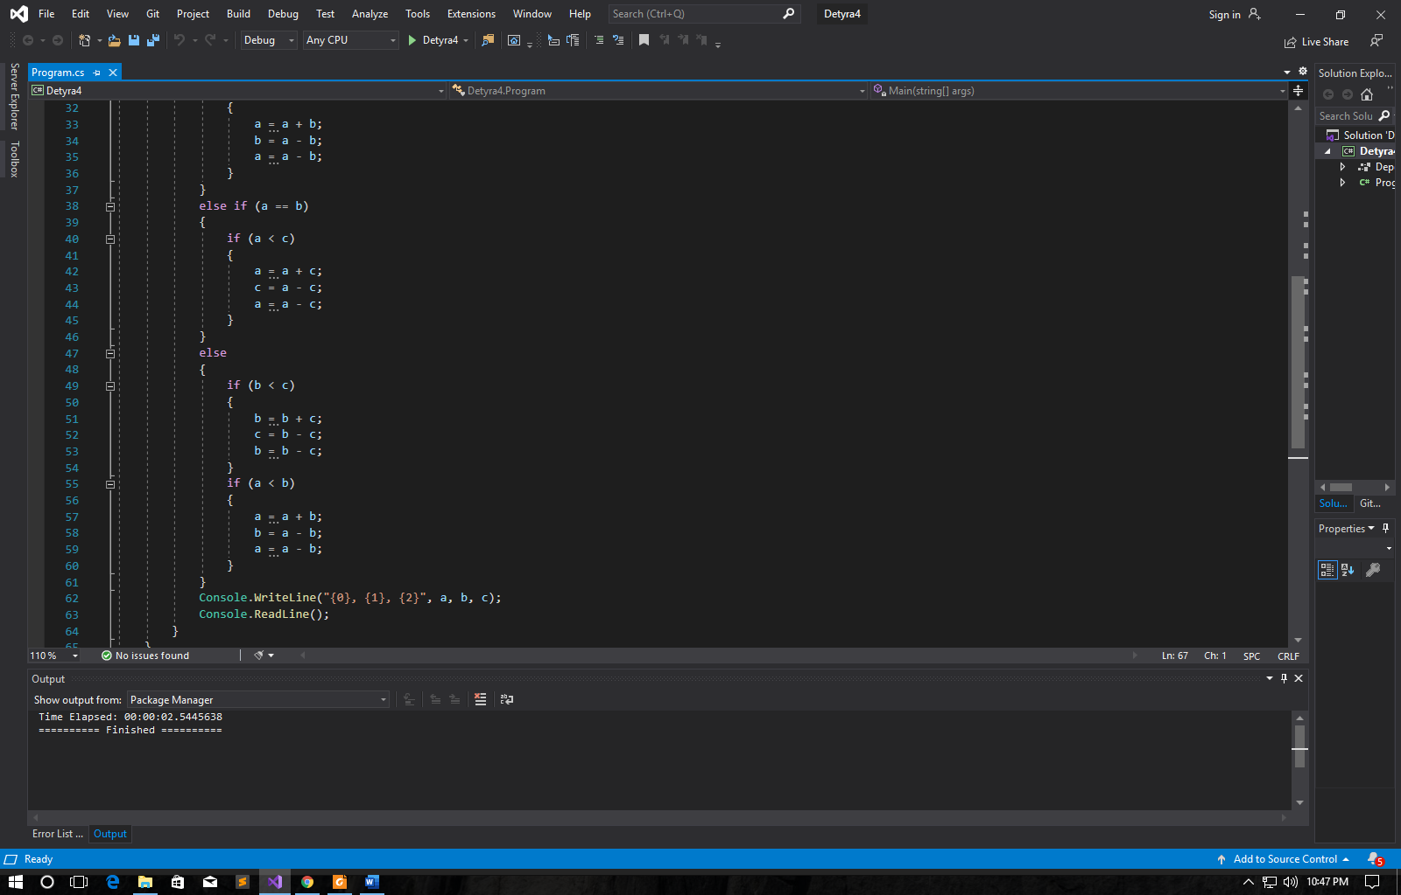

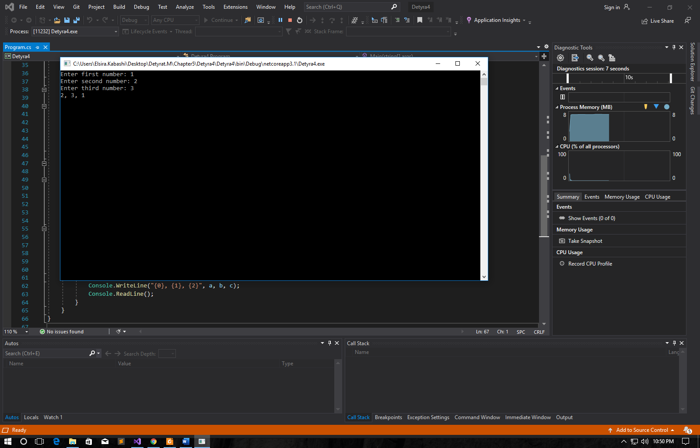

1. Write a program that asks for a digit (0-9), and depending on the input,  
   **shows the digit as a word** (in English). Use a **switch** statement.

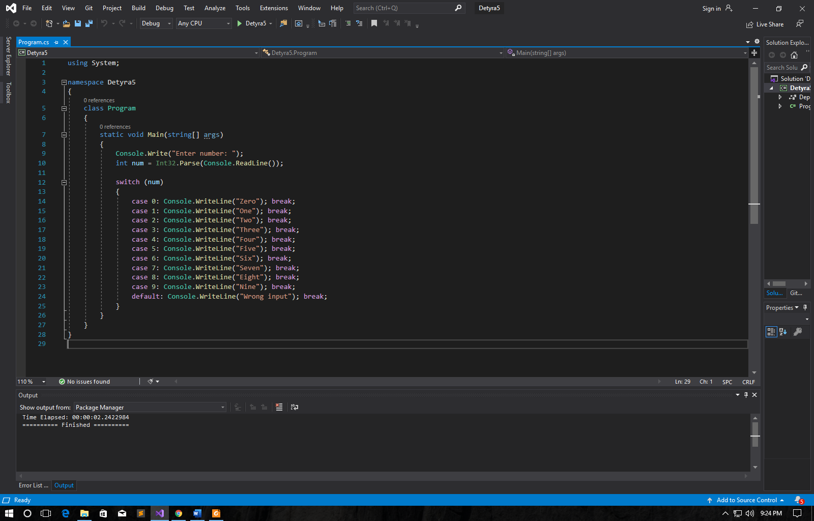

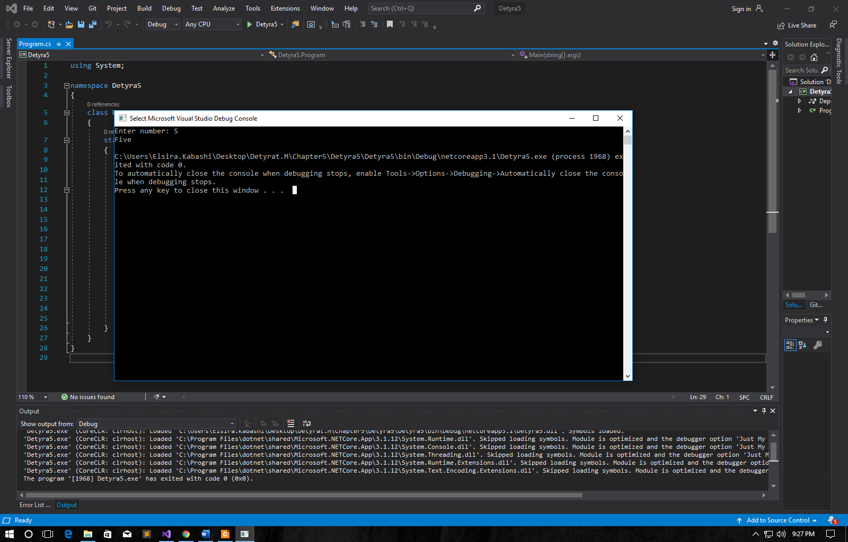

1. Write a program that gets the coefficients ***a***, ***b*** and ***c*** of a quadratic  
   equation: ***a*x2 + *b*x + *c***, calculates and prints its real roots (if they exist).  
   Quadratic equations may have 0, 1 or 2 real roots.

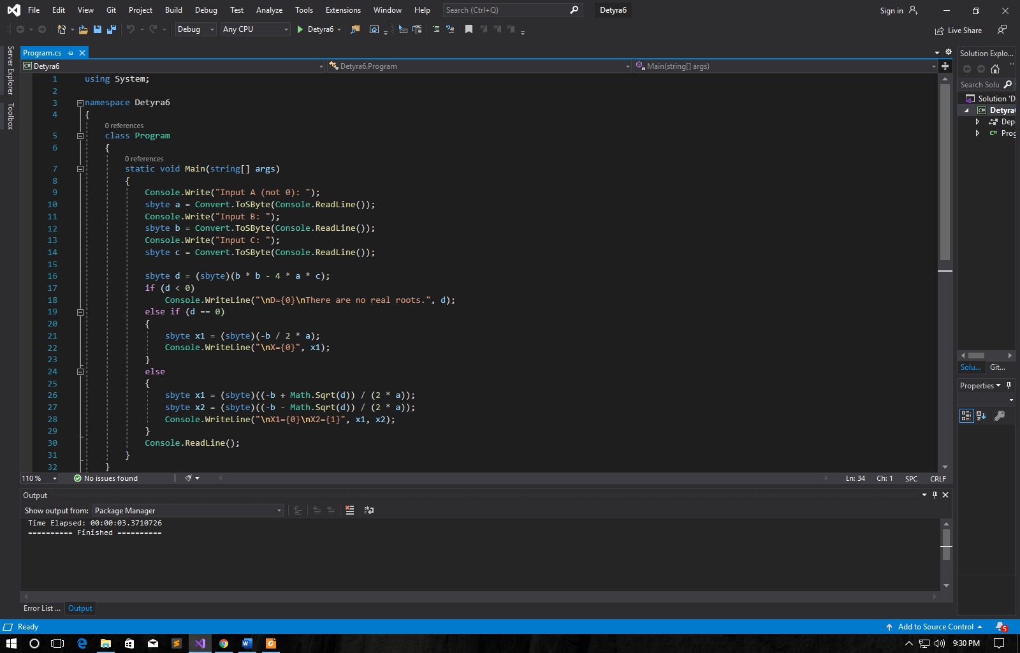

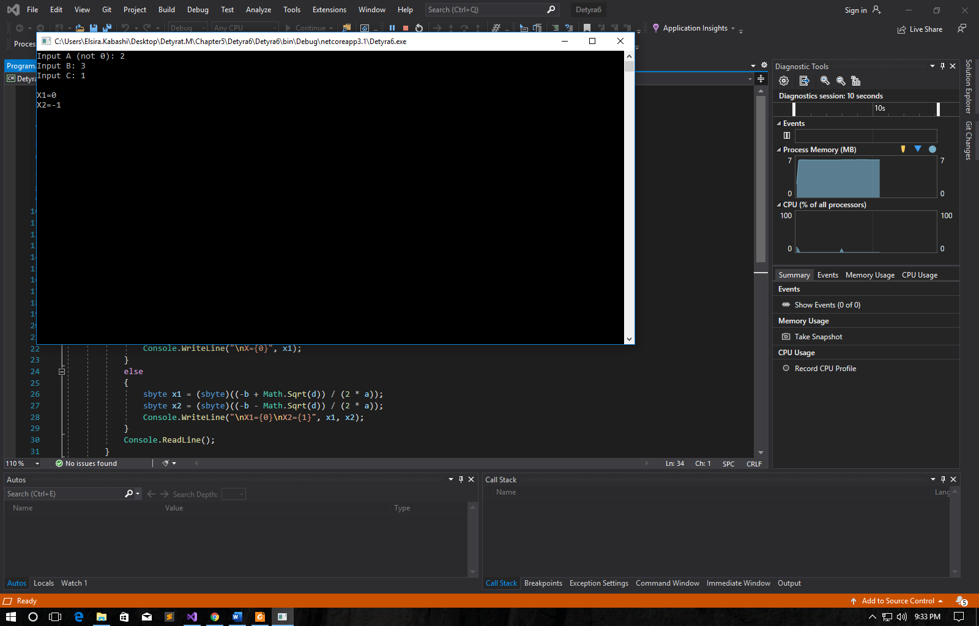

1. Write a program that finds the **greatest of given 5 numbers**.

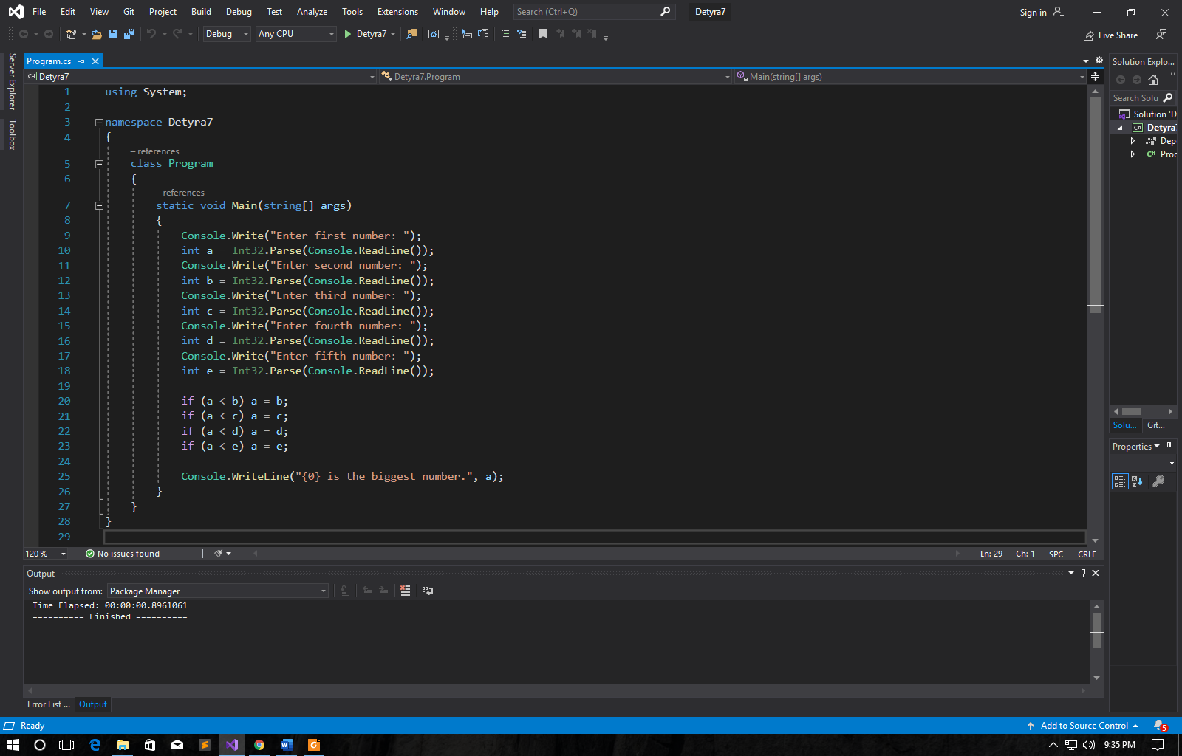

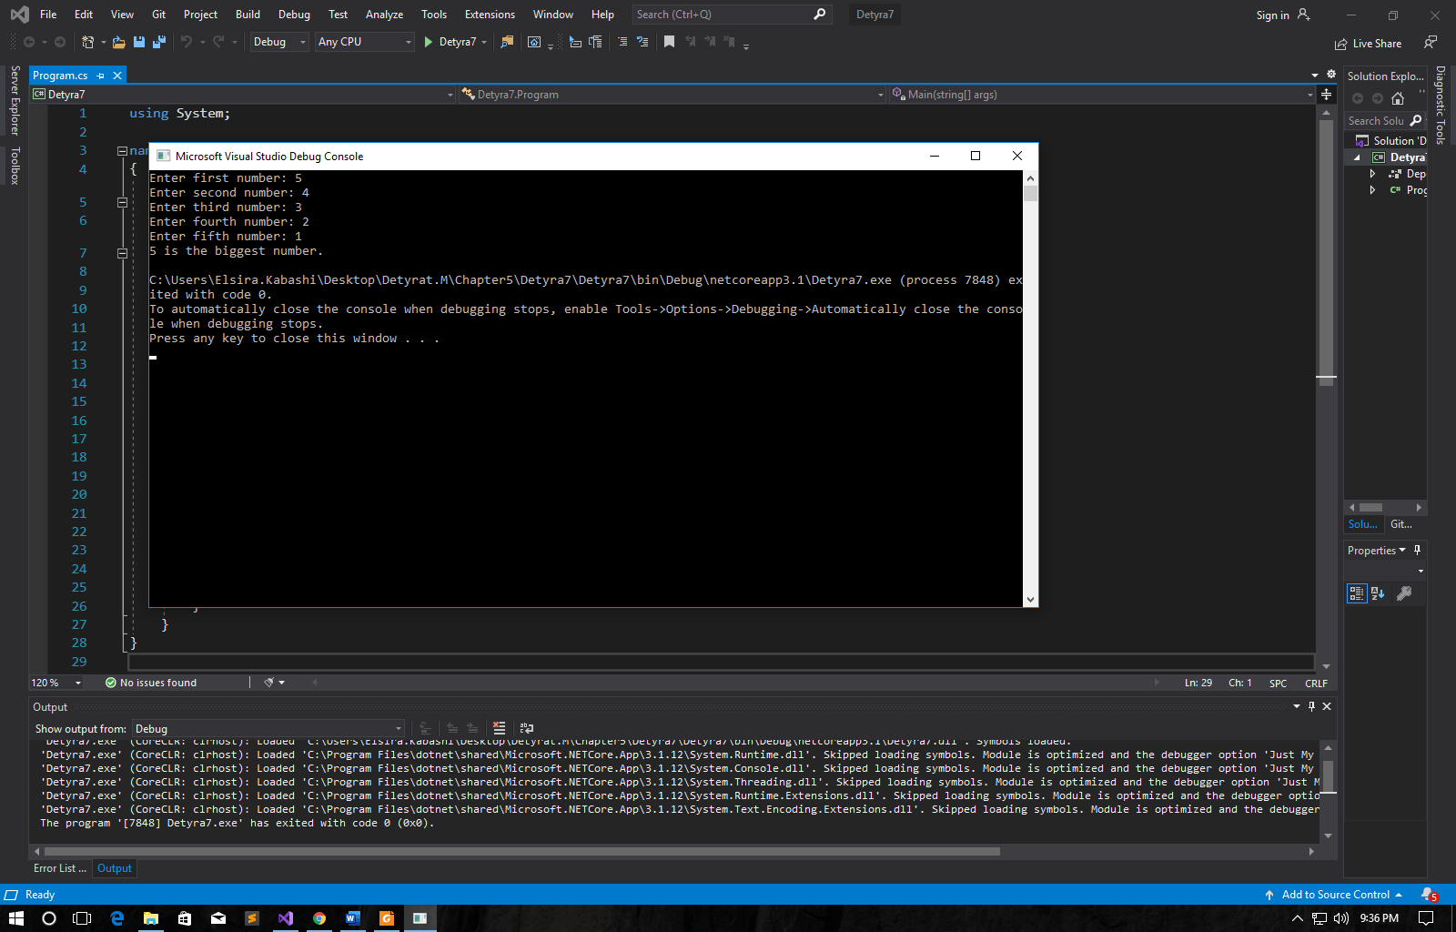

1. Write a program that, depending on the user’s choice, inputs **int**, **double**or **string** variable. If the variable is **int** or **double**, the program  
   increases it by 1. If the variable is a **string**, the program appends "**\***" at  
   the end. Print the result at the console. Use **switch** statement.

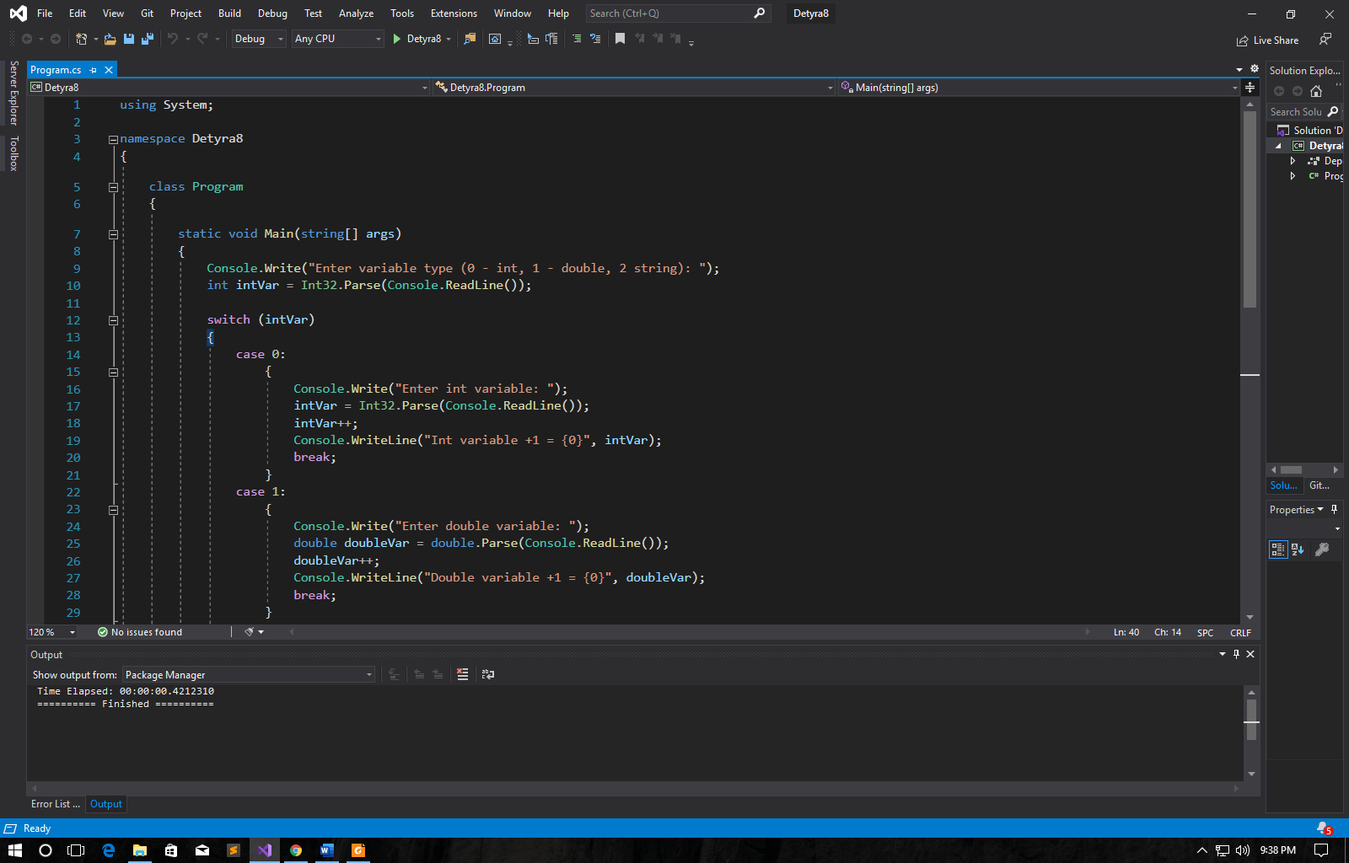 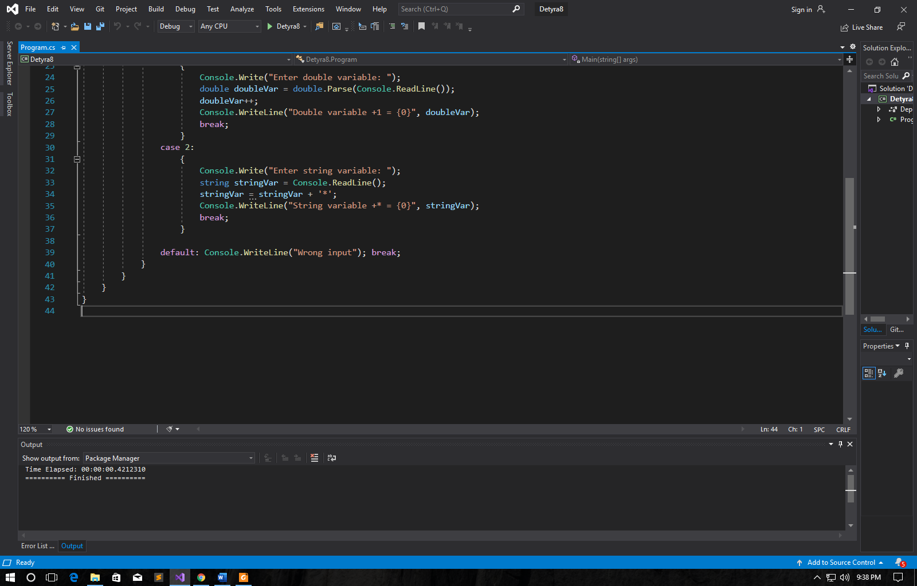

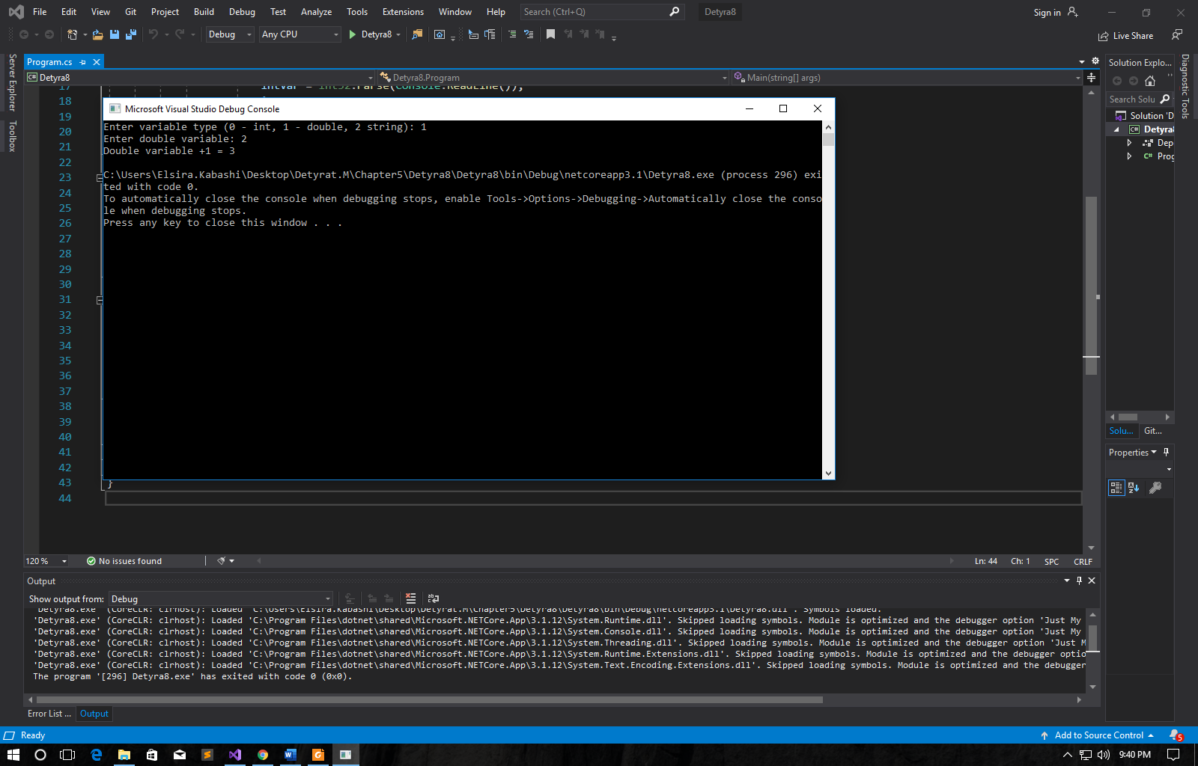

1. We are given 5 integer numbers. Write a program that finds those  
   **subsets whose sum is 0**. Examples:  
   - If we are given the numbers {3, -2, 1, 1, 8}, the sum of -2, 1 and 1  
   is 0.  
   - If we are given the numbers {3, 1, -7, 35, 22}, there are no subsets  
   with sum 0.

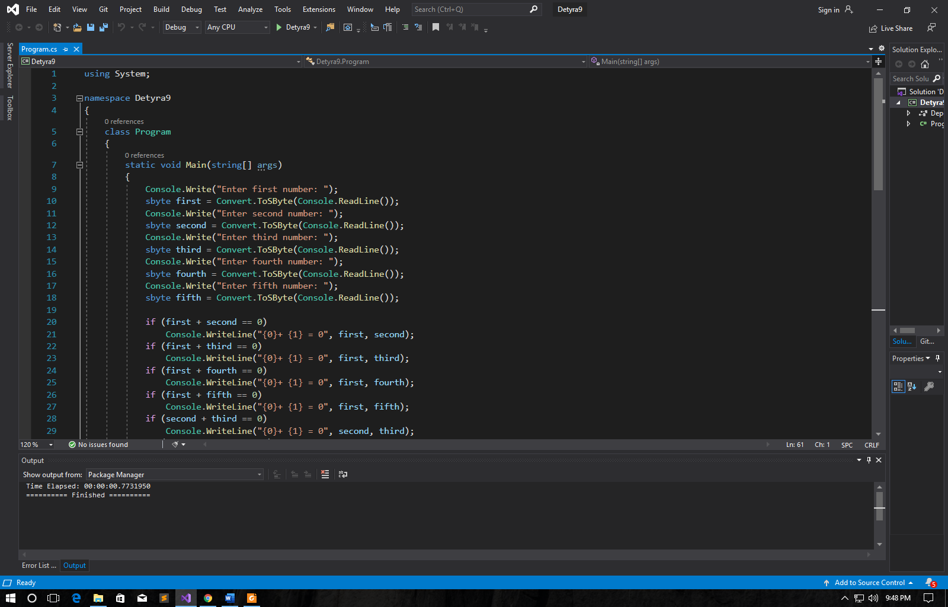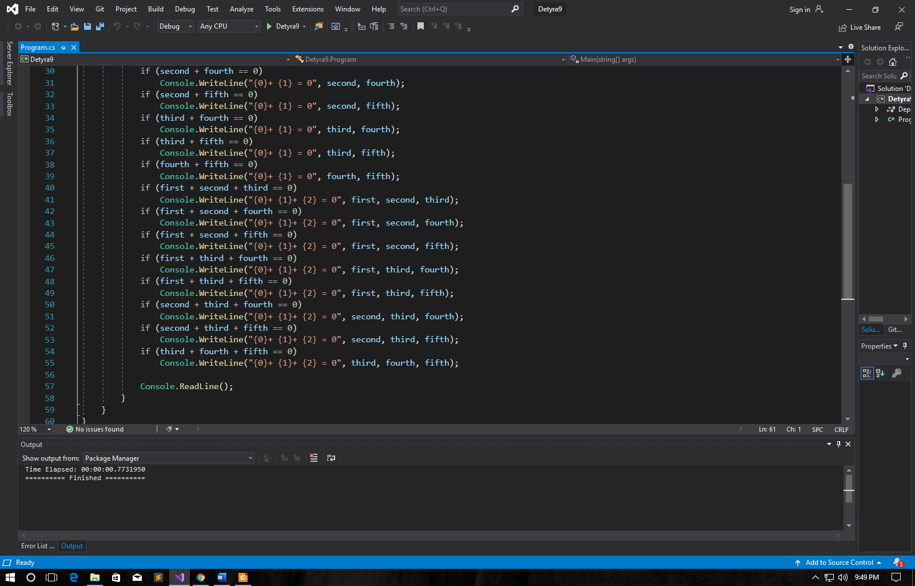

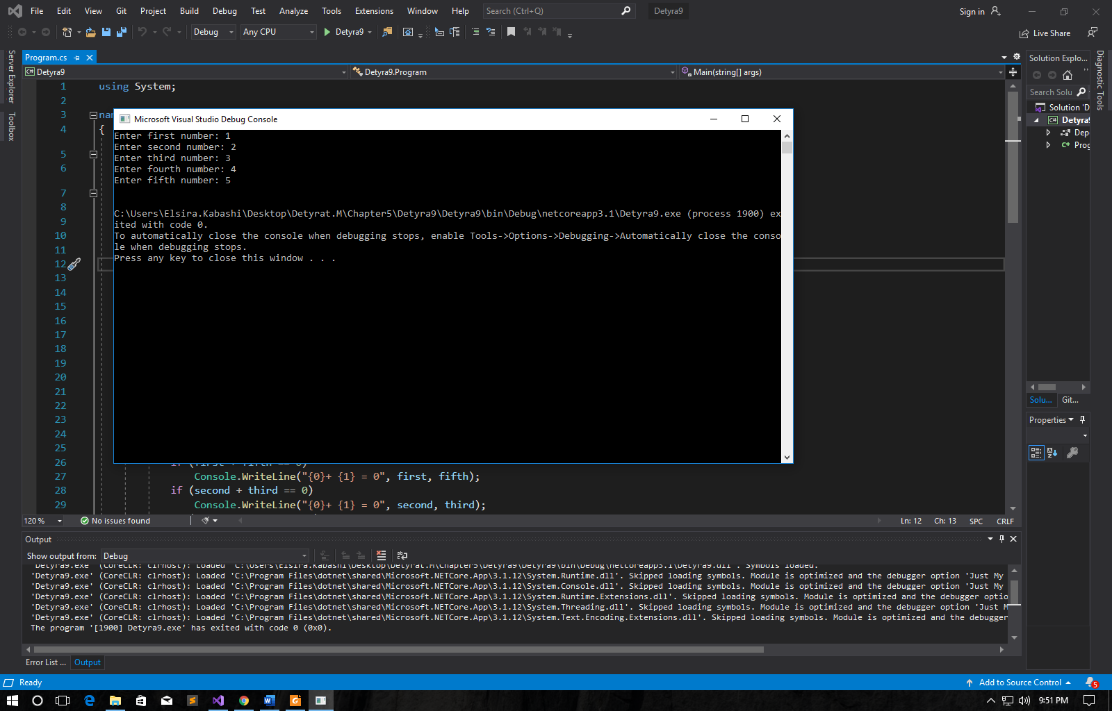

1. Write a program that applies **bonus points** to given scores in the range  
   [1…9] by the following rules:  
   - If the score is between 1 and 3, the program multiplies it by 10.  
   - If the score is between 4 and 6, the program multiplies it by 100.  
   - If the score is between 7 and 9, the program multiplies it by 1000.  
   - If the score is 0 or more than 9, the program prints an error  
   message.

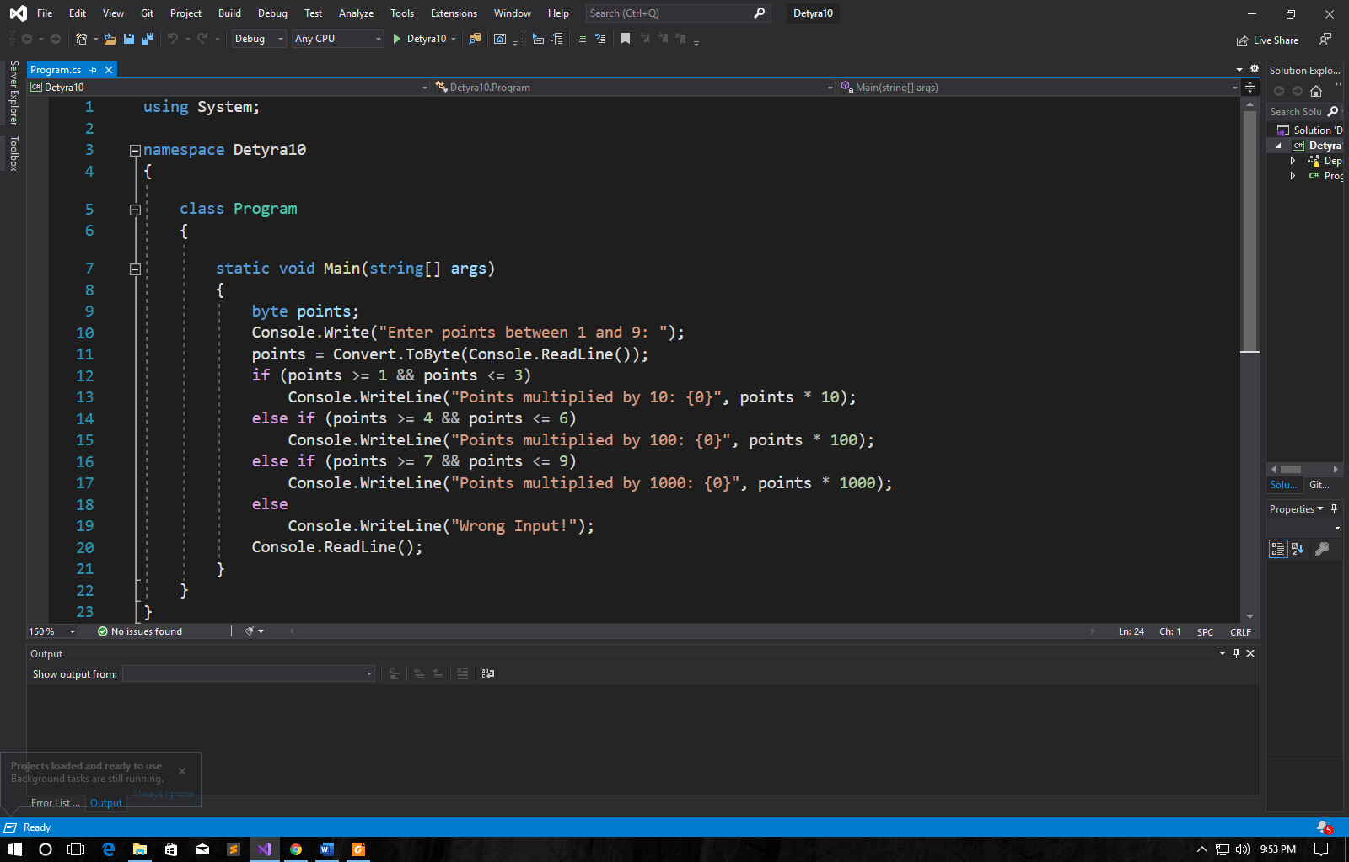

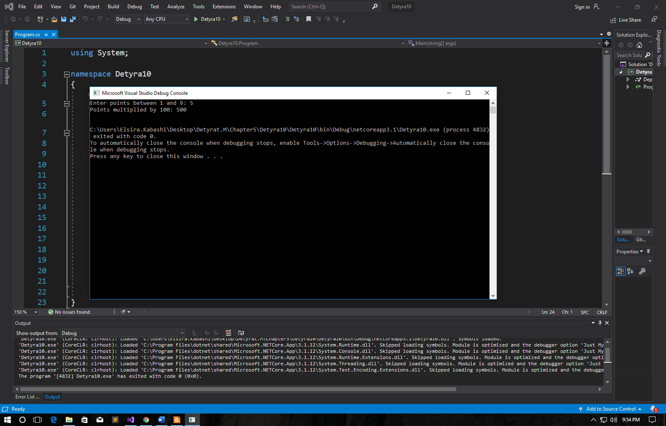

1. * Write a program that **converts a number in the range [0…999] to  
   words**, corresponding to the English pronunciation. Examples:  
   - 0 --> "Zero"  
   - 12 --> "Twelve"  
   - 98 --> "Ninety eight"  
   - 273 --> "Two hundred seventy three"  
   - 400 --> "Four hundred"  
   - 501 --> "Five hundred and one"  
   - 711 --> "Seven hundred a

